View a daily list of cancellations for your agency on our portal

You can now see a list of your agency’s cancellations for the last ten days on the homepage of our agency portal at www.mbgagents.com.

To locate this new feature, look on the right side of the homepage just beneath the list of pending transactions. There you’ll see the number of cancellations.

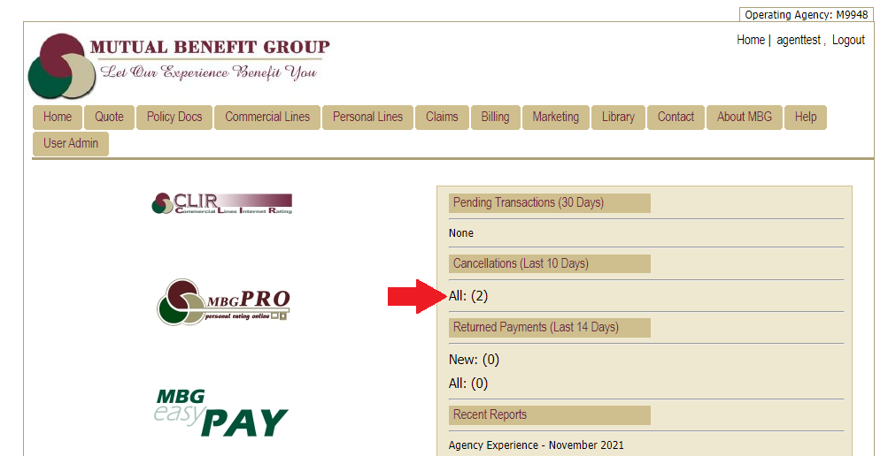

The cancellation feature works the same way as the pending transactions feature. Click on the number of cancellations showing on the screen, and you’ll be taken to a screen showing the policy information for each cancellation (see the example below). If you want to view an account directly, click on the account number.

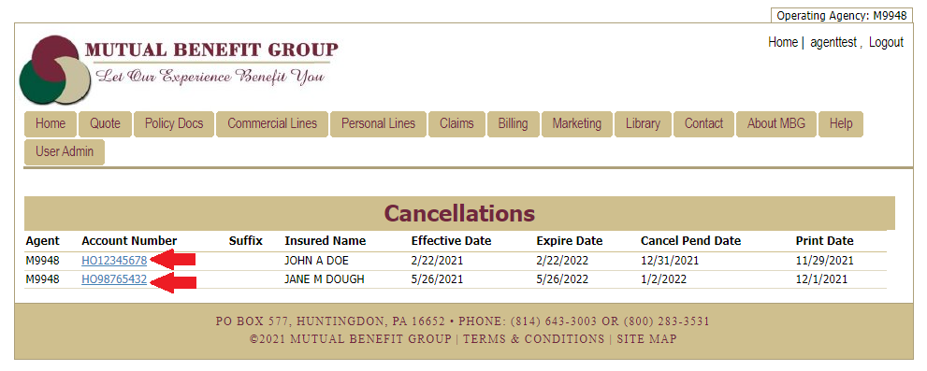

We’re pleased to add this information to our agent portal and hope it will prove helpful in your efforts to retain accounts.

